Penn State Fayette, The Eberly Campus: Emergency Action Plan
Revised 1/13/2022

Introduction
Emergency situations may occur at any time during athletic events. Timely action must be taken in order to provide the best possible care to the sport participant experiencing an emergency and/or life threatening conditions. The development and implementation of emergency action plans (EAP) will help ensure that the best care possible will be provided.
Athletic organizations have a duty to develop an emergency action plan that may be implemented immediately when necessary and to provide appropriate standards of emergency care to all sports participants. Due to the fact that athletic injuries are unpredictable the sports medicine and athletic department must be prepared. The preparation involves formulation of an emergency action plan, proper coverage of events, maintenance of appropriate emergency equipment and supplies, utilization of appropriate emergency medical personnel, and continuing education in the area of emergency medicine and planning. Through careful pre-participation physical screenings, adequate medical coverage, safe practice and training techniques and other safety avenues, some potential emergencies may be averted. However, accidents and injuries are inherent with sports participation, and proper preparation on the part of the sports medicine department should enable each emergency situation to be managed appropriately.

Components of the Emergency Plan
- Contact List
- Emergency Personnel
- Emergency Communication
- Emergency Equipment
- Roles of First Responder
- Venue directions with map

CONTACT LIST
- Campus Police: 724-430-4120
- Athletic Director: 724-430-4281
- Assistant Athletic Director: 724-430-4259
- Athletic Trainer: 724-430-4254
- Campus Maintenance: 724-430-4187

Emergency Plan Personnel
- With athletic practice and competition, the first responder to an emergency is typically a certified athletic trainer of the Penn State Fayette Athletic Training Department, a team physician may not always be present at every organized practice or competition.
  - The type and degree of medical coverage for an athletic event may vary widely, based on such factors as the sport or activity, the setting, and the type of training or competition.
  - The first responder in some instances may be a coach or other college personnel.
  - Certification in cardiopulmonary resuscitation (CPR), Automated External Defibrillator (AED) certified, first aid, prevention of disease transmission, and emergency action plan review is required for all athletics personnel associated with practices, competitions, and skills instruction.
  - Copies of training certificates and/or cards are maintained in the athletic training facility or within the athletic department.
- The development of an emergency action plan cannot be complete without the formation of an emergency team.
- The emergency team may consist of a number of healthcare providers including:
  - Physicians
  - emergency medical technicians
  - certified athletic trainers
  - coaches
  - managers
  - possibly bystanders
- Roles of these individuals within the emergency team may vary depending on various factors such as the number of members of the team, the athletic venue itself, or the preference of the certified athletic trainer on site.
- There are FOUR basic roles within the emergency team:
  - The first and most important role is establishing safety of the scene and immediate care of the athlete.
    - Acute care in an emergency situation should be provided by the most qualified individual on the scene.
    - Individuals with lower credentials should yield to those with more appropriate training.
  - The second role, EMS activation, may be necessary in situations where emergency transportation is not already present at the sporting event.
    - This should be done as soon as the situation is deemed an emergency or a life-threatening event.
    - Time is the most critical factor under emergency conditions.
    - Activating the EMS system may be done by anyone on the team.
    - However, the person chosen for this duty should be someone who is calm under pressure and who communicates well over the telephone.
    - This person should also be familiar with the location and address of the sporting event.
  - The third role, equipment retrieval may be done by anyone on the emergency team who is familiar with the types and location of the specific equipment needed.
    - Managers and coaches are good choices for this role.
  - The fourth role of the emergency team is that of directing EMS to the scene.
    - One member of the team should be responsible for meeting emergency medical personnel as they arrive at the site of the emergency.
    - Depending on ease of access, this person should have keys to any locked gates or doors that may slow the arrival of medical personnel.
    - Campus police, manager, or coach may be appropriate for this role.

Roles within the Emergency Team
1. Establish scene safety and immediate care of the athlete
2. Activation of the Emergency Medical System
3. Emergency equipment retrieval
4. Direction of EMS to scene

Activating the EMS System
Making the Call:
- Call 911 or notify campus police at 724-430-4120.

Providing Information:
- name, address, telephone number of caller
- nature of emergency, whether medical or non-medical *
- number of athletes
- condition of athlete(s)
- first aid treatment initiated by first responder
- other information as requested by dispatcher

When forming the emergency team, it is important to adapt the team to each situation or sport. It may also be advantageous to have more than one individual assigned to each role. This allows the emergency team to function even though certain members may not always be present. Also, if there is a point where there is blood/body fluid spills, please inform campus maintenance of the situation for proper clean up and disinfecting of the area. If they are not available, the Athletic Trainer is also trained and equipped for that sort of clean up as well.

Emergency Communication
Communication is the key to a quick emergency response. Athletic trainers and emergency medical personnel must work together to provide the best emergency response capability and should have contact information such as telephone tree established as a part of pre-planning for emergency situations. Communication prior to the event is a good way to establish boundaries and to build rapport between both groups of professionals. If emergency medical transportation is not available on site during a particular sporting event then direct communication with campus police at the time of injury or illness is necessary.
Access to a working telephone or other telecommunications device, whether fixed or mobile, should be assured. The communications system should be checked prior to each practice or competition to ensure proper working order. A back-up communication plan should be in effect should there be failure of the primary communication system. The most common method of communication is a public telephone. However, a cellular phone is preferred if available. At any athletic venue, whether home or away, it is important to know the location of a workable telephone. Pre-arranged access to the phone should be established if it is not easily accessible.

Emergency Equipment
All necessary emergency equipment should be at the site and quickly accessible. Personnel should be familiar with the function and operation of each type of emergency equipment. Equipment should be in good operating condition, and personnel must be trained in advance to use it properly. Emergency equipment should be checked on a regular basis and use rehearsed prior to the athletic event by emergency personnel. The emergency equipment available should be appropriate for the level of training for the emergency medical providers. Creating an equipment inspection log book for continued inspection is strongly recommended. It is recommended that a few members of the emergency team be trained and responsible for the care of the equipment.
It is important to know the proper way to care for and store the equipment as well. Equipment should be stored in a clean and environmentally controlled area. It should be readily available when emergency situations arise.

Medical Emergency Transportation
EMS response time is additionally factored in when determining on site ambulance coverage. The head certified athletic trainer coordinates on site ambulances for competition only. Ambulances may be coordinated on site for other special events/sports, such as major tournaments or championship events. Consideration is given to the capabilities of transportation service available (i.e., Basic Life Support or Advanced Life Support) and the equipment and level of trained personnel on board the ambulance. In the event that an ambulance is on site, there should be a designated location with rapid access to the site and a cleared route for entering/exiting the venue. In the event of an emergency, calling campus police will still be utilized for activating emergency transport.
In the medical emergency evaluation, the primary survey assists the emergency care provider in identifying emergencies requiring critical intervention and in determining transport decisions. In an emergency situation, the athlete should be transported by ambulance, where the necessary staff and equipment is available to deliver appropriate care. Emergency care providers should refrain from transporting unstable athletes in inappropriate vehicles. Any emergency situations where there is impairment in level of consciousness (LOC), airway, breathing, or circulation (ABC) or there is neurovascular compromise should be considered a “load and go” situation and emphasis placed on rapid evaluation, treatment and transportation. In order to provide the best possible care for Penn State Fayette Athletics, transportation to one of the utilized medical facilities is based upon the strengths of each facility. If a Certified Athletic Trainer or medical professional is unavailable to travel with the athlete, then an assistant coach or Penn State Fayette staff member will go.

Conclusion
The importance of being properly prepared when athletic emergencies arise cannot be stressed enough. An athlete’s survival may hinge on how well-trained and prepared the Penn State Fayette emergency team is in emergent situations. It is prudent to invest athletic department “ownership" in the emergency plan by involving the athletic administration and sport coaches as well as healthcare professionals. The emergency plan should be reviewed at least once a year with all athletic personnel, along with CPR and first aid refresher/certification training. Through development and implementation of the emergency plan, the Athletic Department helps ensure that the athlete(s) will have the best care provided when an emergency situation does arise.

Approved by ____________________________________________ ___________
Head Athletic Trainer Date

Approved by ____________________________________________ ___________
Athletic Director Date

Approved by ____________________________________________ ___________
Assistant Athletic Director Date

Approved by ____________________________________________ ___________
Excela Health Director of Sports Medicine Date

Emergency Plan: Penn State Fayette Community Building (Women’s Volleyball, Men’s Basketball, & Women’s Basketball)

Emergency Personnel: A Certified Athletic Trainer and Team Physician are on site for all competitions; a Certified Athletic Trainer will be present for practices

Emergency Communication: Certified athletic trainer carries cellular telephone (John Anderson 724-771-8096)

Emergency Equipment: Supplies maintained on the home sideline for competition and practices (including AED, trauma kit, splint kit, spine board, crutches).

Roles of First Responders
- Immediate care of the injured or ill student-athlete
2. Activation of emergency medical system (EMS)
- Call 911 and please provide the following:(your name and title, name of location, address, telephone number; number of individuals injured; condition of injured; first aid treatment; specific directions; other information as requested). Also notify campus police at 724-430-4120.
3. Emergency equipment retrieval
4. Direction of EMS to scene
- Open appropriate doors/entrance ways.
- Campus Police will “flag down” EMS and direct to scene
- Scene control: limit scene to first aid providers and move bystanders away from area

Venue Directions: Follow US 119 South to and Penn State Fayette will be on the right. Once you make the right, you will come to a T, turn right. Follow the road till you the Community Center on your left. There will be a small road on the left closest to the Community Center. Make the left down the small road/driveway and the Community Center will be on your right. Campus Police, another athletic trainer, a coach, or the athletic director will escort ambulance from right entrance to the injury site.

Safe Location
Lightning- Penn State Fayette Community Building

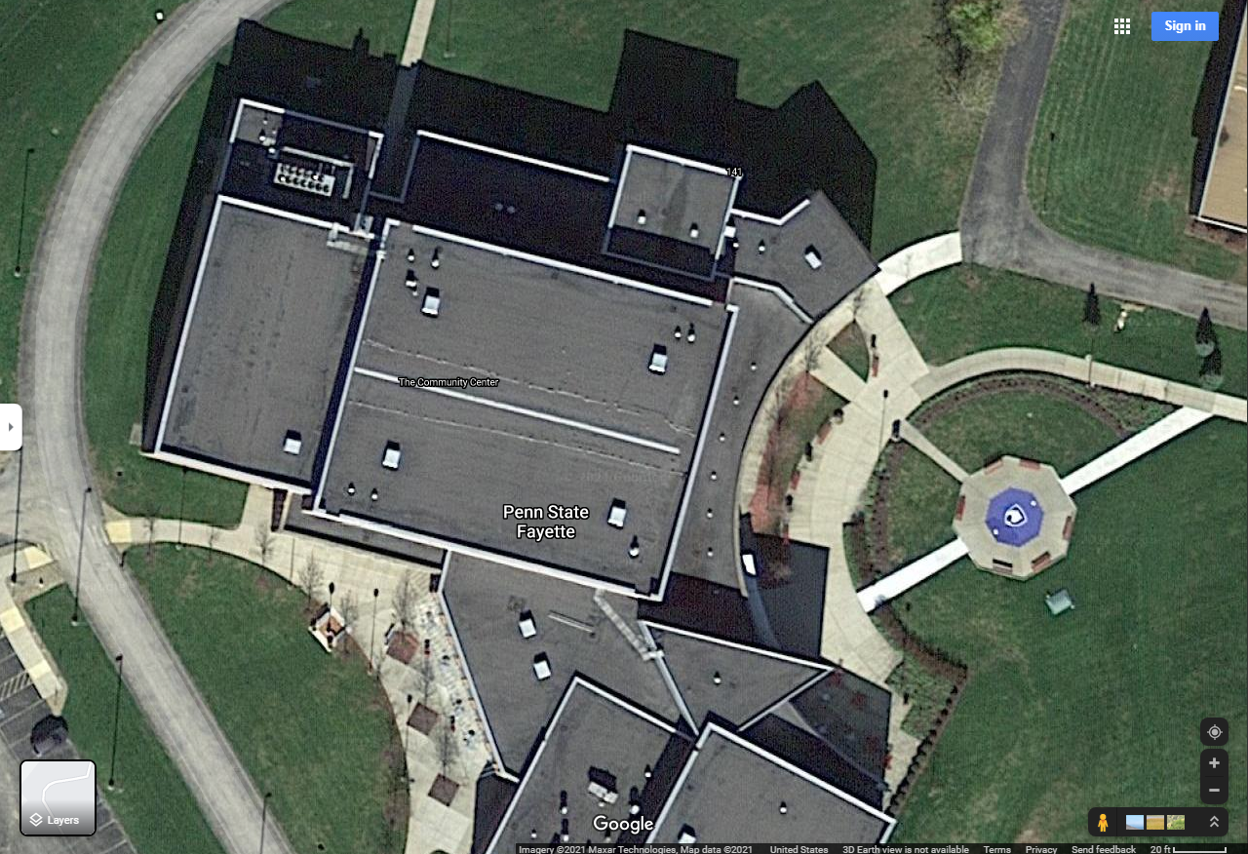
Emergency Plan: Athletic Recreational Center (Volleyball, M&W Basketball, & Track)

Emergency Personnel: A Certified Athletic Trainer will be on site for all competitions and on call for some practices.

Emergency Communication: Certified athletic trainer carries cellular telephone (John Anderson 724-771-8096).

Emergency Equipment:
Center for Community & Public Safety Building: Emergency equipment (splint kit and crutches) located within athletic training facility at the Community Building. AED is mounted on the wall outside the door, closest to the entrance to the Center for Community & Public Safety Building gymnasium.

Roles of First Responders
- Immediate care of the injured or ill student-athlete
- Activation of emergency medical system (EMS)
- Call 911 and provide the following: (your name and title, name of location, address, telephone number; number of individuals injured; condition of injured; first aid treatment; specific directions; other information as requested). Also, notify campus police at 724-430-4120.
- Emergency equipment retrieval
- Direction of EMS to scene
- Open appropriate doors/entrance ways
- Campus Police will “flag down” EMS and direct to scene
- Scene control: limit scene to first aid providers and move bystanders away from area

Venue Directions: Follow US 119 South to and Penn State Fayette will be on the right. Once you make the right, you will come to a T, turn right. Follow the road till you see the library straight ahead. There will be a right turn and another sharp right turn. Follow that road and the Center for Community & Public Safety Building will be on your right. Campus Police, another athletic trainer, a coach, or the athletic director will escort ambulance from right entrance to the injury site.

Safe Location
Lightning- Center for Community & Public Safety Building locker rooms and hallways.
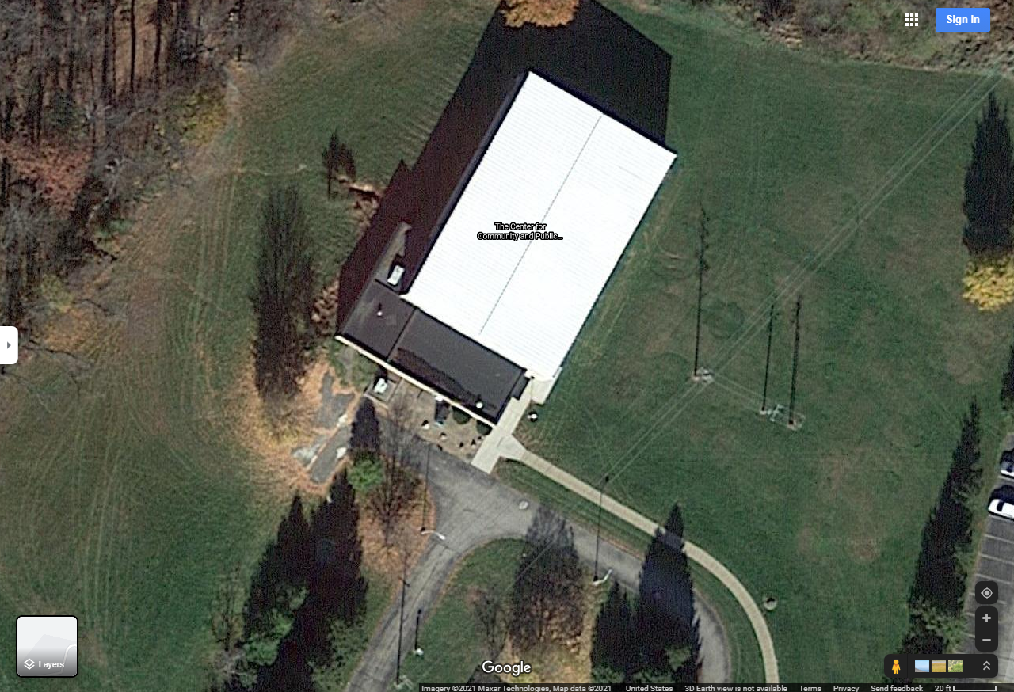
Emergency Plan: Baseball & Softball On Campus Complex

Emergency Personnel: A Certified Athletic Trainer on site for competition; additional sports medicine staff accessible from the Community Building athletic training facility.

Emergency Communication: Athletic Trainer carries cellular telephone (John Anderson 724-771-8096).

Emergency Equipment: Supplies (AED, splint kit) maintained on site during competition and practice. Additional emergency equipment will be accessible from the athletic training room within the Community Center Building.

Roles of First Responders
- Immediate care of the injured or ill student-athlete
- Activation of emergency medical system (EMS)
- Call 911 and provide the following: (your name and title, the name of the location where you are at, address, telephone number; number of individuals injured; condition of injured; first aid treatment; specific directions; other information as requested). Also, notify campus police at 724-430-4120.
- Emergency equipment retrieval
- Direction of EMS to scene
- Open appropriate gates
- Campus Police or a bystander will “flag down” EMS and direct to scene
- Scene control: limit scene to first aid providers and move bystanders away from area

Venue Directions: Follow US 119 South to and Penn State Fayette will be on the right. Once you make the right, you will come to a T, turn right. Follow the road till the Community Center is on your left. Keep following the road till your behind the Community Center and where there will be a parking lot located for the Softball field access. If you keep following the road down to the maintenance building on the right there will be a gate for you to access to get into the baseball field. Campus Police, another athletic trainer, a coach, or the athletic director will escort ambulance from right entrance to the injury site.

Safe Location
Lightning- Head to the nearest shelter that is grounded from the storm
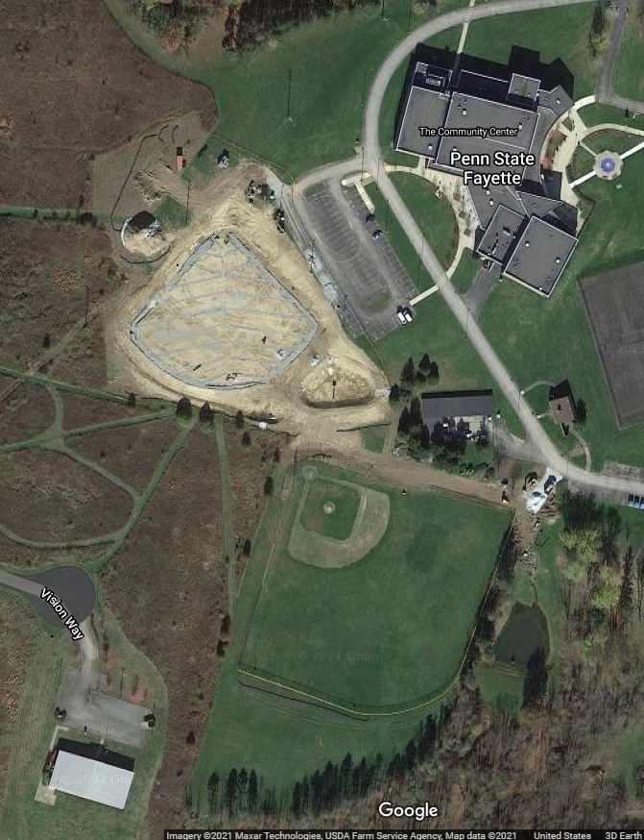
Emergency Plan: Uniontown High School Athletic Field (Track/Soccer)
Address: 146 E. Fayette Street Uniontown, PA 15401

Emergency Personnel: A Certified Athletic Trainer on site for competition; additional sports medicine staff accessible from the Community Building athletic training facility, if available.

Emergency Communication: Athletic Trainer carries cellular telephone (John Anderson 724-771-8096).

Emergency Equipment: Supplies (AED, splint kit) maintained on site during competition and practice.

Roles of First Responders
- Immediate care of the injured or ill student-athlete
- Activation of emergency medical system (EMS)
- Call 911 and provide the following: (your name and title, the name of the location where you are at, address, telephone number; number of individuals injured; condition of injured; first aid treatment; specific directions; other information as requested). Also, notify Uniontown High School police at 724-438-4501 x 1611.
- Emergency equipment retrieval
- Direction of EMS to scene
- Open appropriate gates
- Campus Police or a bystander will “flag down” EMS and direct to scene
- Scene control: limit scene to first aid providers and move bystanders away from area

Venue Directions: From Penn State Fayette you will go on US 119 South. Then you will go 5.3 miles and take the US-40 W exit toward US 40 BUS/Main Street. After that go 0.3 miles turn left on US-40 E/US-40 BUS E/W Main Street. Then go 0.8 miles and continue straight onto W Fayette Street. After that go 0.7 miles and turn right onto S Grant Street. After that go 300 feet and turn right. Then at 0.1 miles Uniontown Athletic Field will be on your right. Ambulance will enter from the main stadium side closest to the school. Campus Police, another athletic trainer, a coach, or the athletic director will escort ambulance from right entrance to the injury site.

Safe Location
Lightning- Head to the nearest shelter that is grounded from the storm under the stadium
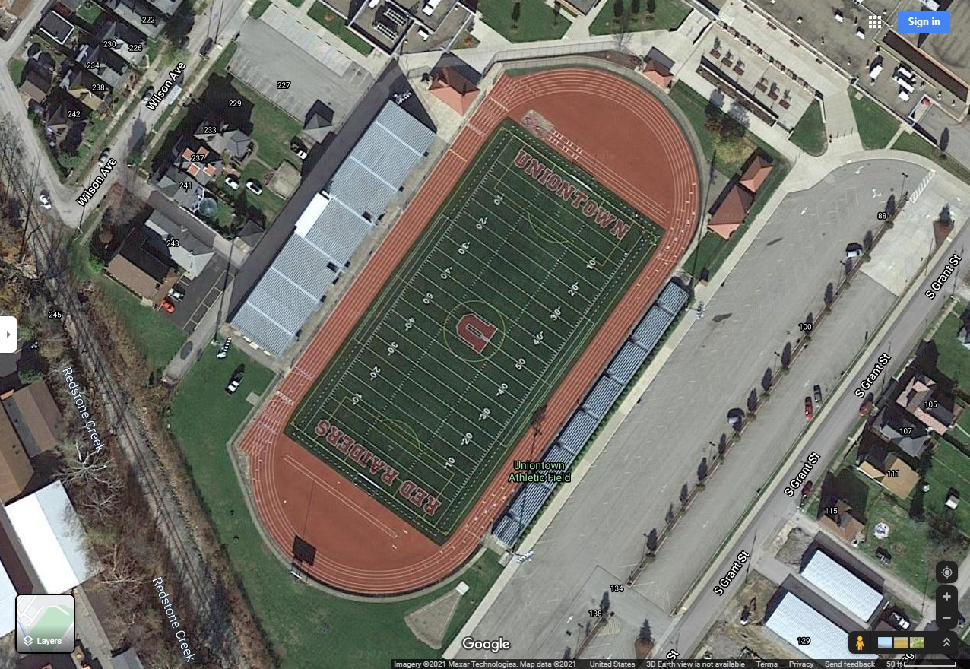
Emergency Plan: Penn State Fayette, The Eberly Campus (Cross Country)

Emergency Personnel: A Certified Athletic Trainer on site for competition.

Emergency Communication: Athletic Trainer carries cellular telephone (John Anderson 724-771-8096).

Emergency Equipment: Supplies (AED, splint kit, med-kit) maintained on site during competition and practice.

Roles of First Responders
- Immediate care of the injured or ill student-athlete
- Activation of emergency medical system (EMS)
- Call 911 and provide the following: (your name and title, the name of the location where you are at, address, telephone number; number of individuals injured; condition of injured; first aid treatment; specific directions; other information as requested). Also, notify Penn State Fayette, the Eberly Campus police at 724-430-4120.
- Emergency equipment retrieval
- Direction of EMS to scene
- Open appropriate gates (if applicable)
- Campus Police or a bystander will “flag down” EMS and direct to scene
- Scene control: limit scene to first aid providers and move bystanders away from area

Campus Police, another athletic trainer, a coach, or the athletic director will escort ambulance from right entrance to the injury site.

Safe Location
Lightning- Head to the nearest shelter that is grounded from the storm.

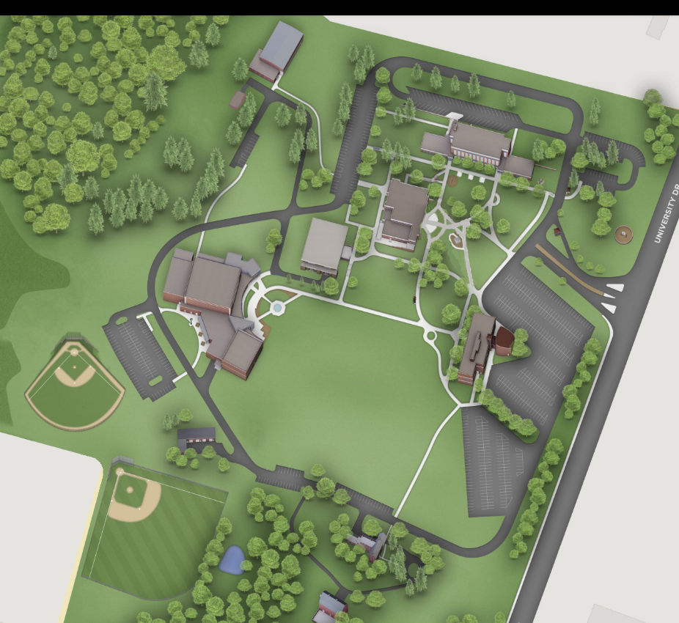

Emergency Plan: Hutchinson Park (Baseball)
Address: 65 Reservoir Road, Uniontown, PA 15401

Emergency Personnel: A Certified Athletic Trainer on site for competition.

Emergency Communication: Athletic Trainer carries cellular telephone (John Anderson 724-771-8096).

Emergency Equipment: Supplies (AED, splint kit) maintained on site during competition and practice.

Roles of First Responders
- Immediate care of the injured or ill student-athlete
- Activation of emergency medical system (EMS)
- Call 911 and provide the following: (your name and title, the name of the location where you are at, address, telephone number; number of individuals injured; condition of injured; first aid treatment; specific directions; other information as requested).
- Emergency equipment retrieval
- Direction of EMS to scene
- Open appropriate gates (if any)
- Campus Police or a bystander will “flag down” EMS and direct to scene
- Scene control: limit scene to first aid providers and move bystanders away from area

Campus Police, another athletic trainer, a coach, or the athletic director will escort ambulance from right entrance to the injury site.

Safe Location
Lightning- Head to the nearest shelter that is grounded from the storm.
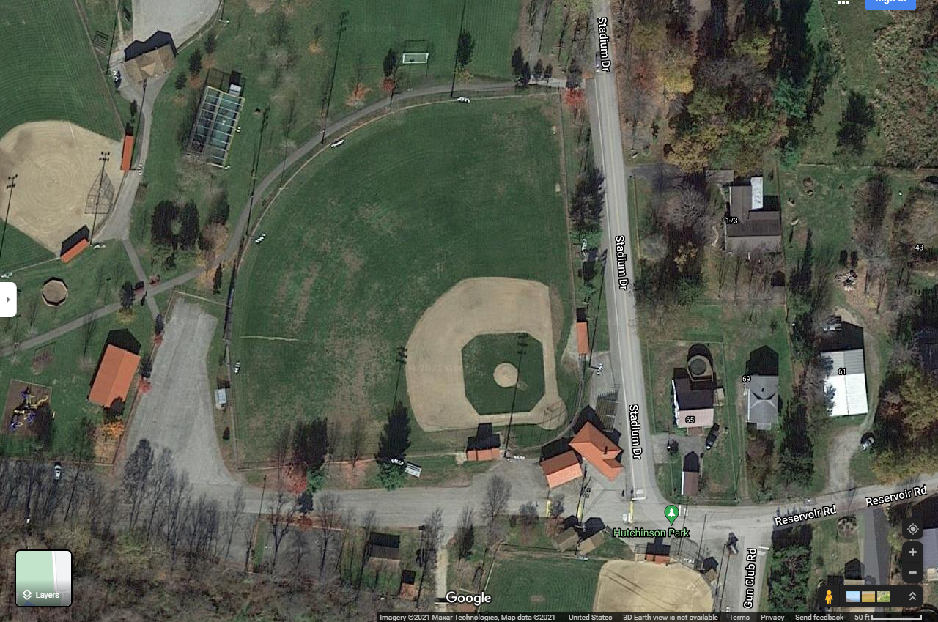

Emergency Plan: RW CLARK/Eberly Park (Softball)
Address: Uniontown Ballfield, 100-168 Oliver Boulevard, Uniontown, PA 15401

Emergency Personnel: A Certified Athletic Trainer on site for competition.

Emergency Communication: Athletic Trainer carries cellular telephone (John Anderson 724-771-8096).

Emergency Equipment: Supplies (AED, splint kit) maintained on site during competition and practice.

Roles of First Responders
- Immediate care of the injured or ill student-athlete
- Activation of emergency medical system (EMS)
- Call 911 and provide the following: (your name and title, the name of the location where you are at, address, telephone number; number of individuals injured; condition of injured; first aid treatment; specific directions; other information as requested).
- Emergency equipment retrieval
- Direction of EMS to scene
- Open appropriate gates (if any)
- Campus Police or a bystander will “flag down” EMS and direct to scene
- Scene control: limit scene to first aid providers and move bystanders away from area

Campus Police, another athletic trainer, a coach, or the athletic director will escort ambulance from right entrance to the injury site.

Safe Location
Lightning- Head to the nearest shelter that is grounded from the storm.
