

2024 ROARING LIONS INVITATIONAL
Hosted by Penn State Fayette
___________________________________________________________________

Date: Saturday, September 28, 2024

Location: Penn State Fayette, The Eberly Campus
Community Center
2201 University Dr.
Lemont Furnace, PA 15456

Parking Buses/Vans will drop teams off at the designated drop-off location indicated on the map below and park in Biomedical Building parking lot (see map on page 3).

Race Day Contact Info: Stephen Oberly, Fayette AD, 724-415-8130 (c); 724-430-4281 (o)
Samantha Swetz, Fayette Assistant AD, 724-430-4259 (o)

Schedule: Course Walk-thru → 10:00 to 11:30 a.m.
Course Cleared → 11:45 a.m.
Coaches Meeting → Noon
Women’s 6K → 12:30 p.m.
Men’s 8K → Will begin 5 minutes after the completion of the women’s race

Course: Women: 2 x 3k loops, 6k – 3.67 miles. (MAP BELOW)
Video https://www.relive.cc/view/r10007361581

Men: 2 x 4k loops, 8k – 4.97 miles (MAP BELOW)
Video -> https://www.relive.cc/view/r10007361577

Entry Fees: $150.00 per gender / $300.00 for men and women teams
$30 individual (up to 4 per gender)

Entry Procedure: 1) Complete the RSVP link and register you participants on DirectAthletics
Deadline is Tuesday, September 24, 2024
Each participant will receive a timing chip

Scoring: Electronic Timing System: Gingerbread Timing Company
Results will be forwarded to all participating teams

Athletic Training Services: Trainer will be on-site by 9:00 a.m.
Each school should supply their own med kit

Post-Race awards and meals: Awards will be on site following Men’s race in the Athletic and Recreation Center (ARC). We will provide awards for top three teams and top individual in each gender. We will also hand out t-shirts to the top ten placers. Sandwich/wraps, fruit, chips, cookies, and a drink will be provided to all participants.
Restrooms: Restrooms will be available in the Community Center and Athletic and Recreation Center (ARC). NO CLEATS are permitted when indoors.

Women’s’ Course Map
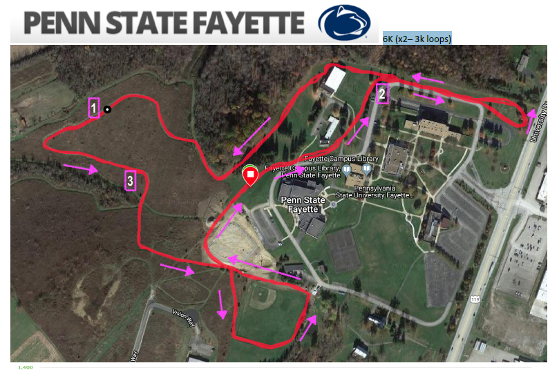

Men’s Course Map
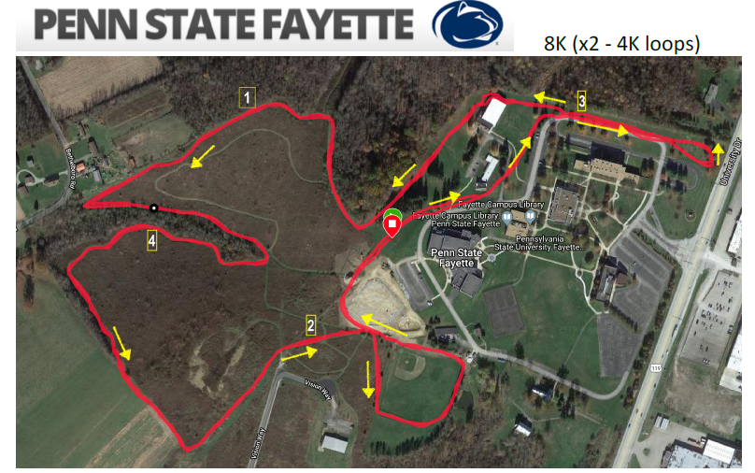

Campus and Event Map
